HOME LEARNING
YEAR 2 |  | AROUND THE WORLD |  |  | Date: 3.6.2020
MATHS |  |  |  |  |  |  | 45 minutes
Warm up – Draw a 4 sided shape, draw a 3 sided shape, draw a six sided shape, draw a 2 sided shape. Label these shapes.

Using your ruler, I would like you to practise drawing lines and labelling the centimetres. Draw these lines: 5cms, 9cms, 16cms, 25cms, 27cms, 14.5cms, 12.5cms. Can you draw some of your own lines and label how long they are.
How long is this piece of string? What would you need to do to find out? Write the steps. 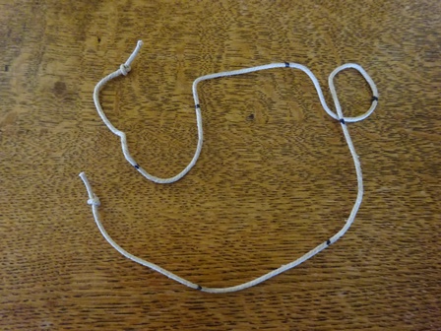
This Photo by Unknown Author is licensed under CC BY-NC-ND
100 centimetres is the same as 1 metre. Show you would measure smaller things using centimetres and bigger things using metres. Draw and label 5 objects that you would measure using centimetres and 5 objects you would measure using metres.

ENGLISH
Reading 20 mins  Visit Cbeebies Bedtime Stories.  Listen to ‘Ruby’s Worry’ read by Katie Piper.  Answer these questions.  - What does Ruby’s worry start to do?  - Could anyone else see Ruby’s worry?  - What is the worst thing you can do with a worry?  - What did Ruby realise when she met the little boy?  - What should you do if you have a worry? |  |  | Spelling 10 mins  Your spellings this week are;  station, lotion, potion, fiction, motion, section, caption, option, nation, attention  Play hangman with a partner, using the above words. Add some common exception words too.  Choose 3 different words and put them in a sentence. |  |  | Writing 30 mins  Opposites  A person or thing that is totally different from or the reverse of someone or something.  Match these opposites together.  fast, long, hot, wild, sad, hard, wet, open noisy, near  match with  happy, soft, far, dry, slow, short, tame, quiet, cold, shut
PHYSICAL ACTIVITY- Choose one |  |  |  |  |  |  | 30 minutes
Joe Wicks Work Out  9am The Body Coach on You Tube or use a uploaded video.  Run around your back garden for 30 minutes.  Play catch or kick a football with someone in your family.  Use a skipping rope/hula hoop/trampoline if you have one.  Do some boxing into a pillow (ask a grown up to hold the pillow) |  |  |  | Oti Mabuse Dance  11.30 Oti Mabuse Official on You Tube  or use previous uploaded video  Go for a walk with your family.  Do some gardening.  Go for a ride on your bike  Try ‘yoga for kids’ on You Tube
THEMED LEARNING
Look at an atlas and find a map of the world, can you use post-it notes to label the continents; Asia, Africa, North America, South America, Australia, Antarctica and Europe.
Can you find these countries; France, Germany, China, Italy, Jamaica, Mexico, New Zealand, Nigeria and Pakistan.
Put these countries in alphabetical order.
Can you find the flags for each of these countries?

TEAM PLAYER SKILL
Feed the family pet

INDEPENDENCE SKILL
Brush and style your own hair.

